This capture shows DNS resolution activity from a local device (10.218.252.191) to a DNS server (10.218.252.84). The device is resolving several cloud service domains, including Microsoft Graph, Microsoft Edge, Sentry.io, and Google adtrafficquality. These domains are commonly used for cloud APIs, browser telemetry, and application error reporting. The presence of TCP retransmissions suggests either normal Wi-Fi instability or delayed responses from upstream servers. This capture demonstrates the first stage of an HTTP/HTTPS transaction: DNS resolution.
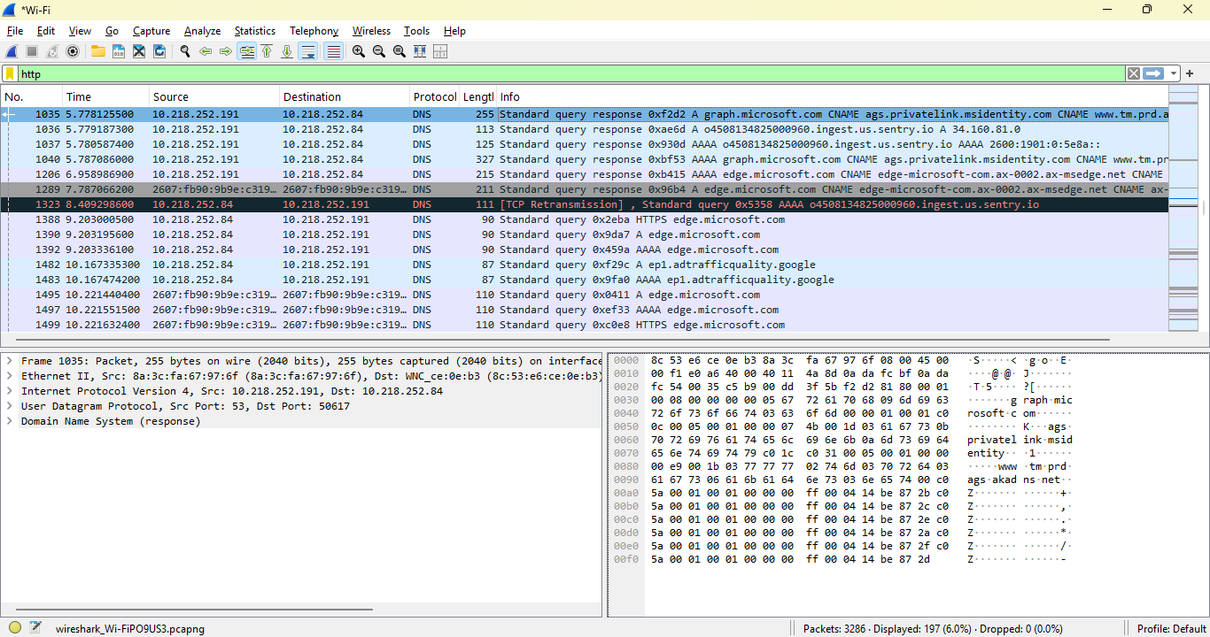
What’s been learned?
This capture shows this device performing DNS lookups for multiple cloud services (Microsoft, Google, Sentry.io). DNS is the “phone book” of the internet — before any HTTP or HTTPS connection happens, this system must resolve domain names to IP addresses. These DNS queries reveal what services this system is trying to communicate with.
What the capture shows (interpreting the screenshot)
✔ 1. This device is making DNS queries
Source: 10.218.252.191 Destination: 10.218.252.84 Protocol: DNS (UDP)
This means the device is asking a DNS server on this network to resolve domain names.
✔ 2. The domains being queried are cloud services
We thus get DNS queries for:
- graph.microsoft.com
- edge.microsoft.com
- ingest.us.sentry.io
- adtrafficquality.google
These are all legitimate cloud endpoints:
- Microsoft Graph → identity, cloud API calls
- Microsoft Edge → browser telemetry
- Sentry.io → error logging/telemetry
- Google adtrafficquality → ad fraud detection
This is normal background traffic for Windows, Edge, and apps using cloud APIs.
✔ 3. Some TCP retransmissions appear
Also have:
- TCP retransmissions
- Possibly failed connections
- Possibly delayed responses
This is common on Wi-Fi networks and not necessarily malicious.
But in SOC work, retransmissions can also indicate:
- Firewall interference
- Packet loss
- Malware beaconing failing
- Scanning behavior
- Unstable connections
This is why analysts pay attention to them.

